**Q1**

**a):**

**Brain storm**

* Input images shot by stereo cameras.
* Need to find a way to detect circles.
* Need a dataset of images of tennis balls and train a classifier to decide whether a patch contain tennis ball.
* Need a dataset of images of tennis players and train a classifier to decide whether a patch contain tennis player.
* Need to compute depth and 3D location.
* Need to analyze the optimal decision on where to proceed.
* Need to avoid player during matching.

**b):**

**Flow chart**

* For simplicity, I did not consider dropping off balls.
* Assume (X, Y, Z) is in camera’s coordinates.
* Since the robot should work during match. Then there might be balls to collect even if the robot has collected all balls already on the court. Then I decided that the robot will not stop unless someone manually turned it off.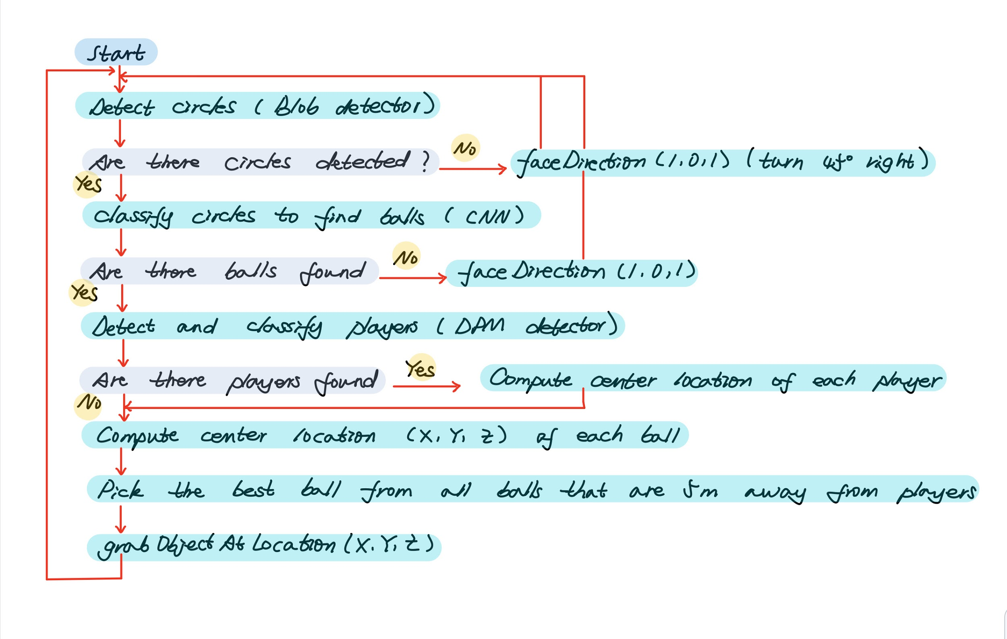

**c):**

**Pseudo code**

% start

While not turned off

Get image_left

Get image_right

% return a list of patches of circles detected

Circles = blobDetector(image_left)

If length(circles) == 0

faceDirection(1, 0, 1)

Continue

End if

% return a sublist of circles that are classified to be balls

Balls = CNN(circles)

If length(balls) == 0

faceDirection(1, 0, 1)

Continue

End if

% algorithm implemented in q2

% given patches, return a list of center location correspond to each patch

Ball_locations = q2(balls)

%return a list of patches of players

Players = DPMPersonDetector(image_left)

% compute location of players and exclude balls that are too close to some player

If length(players) > 0

Player_locations = q2(players)

For player_location in player_locations

For ball_location in ball_locations

If norm(player_location, ball_location) < 5

ball_locations.remove(ball_location)

End if

End for

End for

End if

% pick the closest ball to collect

If length(ball_locations) > 0

(X, Y, Z) = minNorm(ball_locations)

grabObjectAtLocation(X, Y, Z)

End if

End while

**Q2**

**a):**

**Compute depth**

**Q2_a.m:**

globals;

imnames = {'004945', '004964', '005002'};

for i = 1:length(imnames)

imname = imnames{i};

% compute depth

camera_parameters = getData(imname, 'test', 'calib');

f = camera_parameters.f;

T = camera_parameters.baseline;

disparity_struct = getData(imname, 'test', 'disp');

disparity = disparity_struct.disparity;

depth = f*T./(disparity);

% save depth

depth_filename = fullfile(RESULTS_DIR, strcat(imname, '_depth.mat'));

save(depth_filename, 'depth');

% plot depth

fig = figure('position', [100, 100,size(disparity,2)*0.7, size(disparity,1)*0.7]);

subplot('position', [0,0,1,1]);

imagesc(depth, [0,256]);

axis equal;

% save result

result_name = fullfile('../results', strcat('q2_a_', imname, '.png'));

saveas(fig, result_name);

End

**Results:**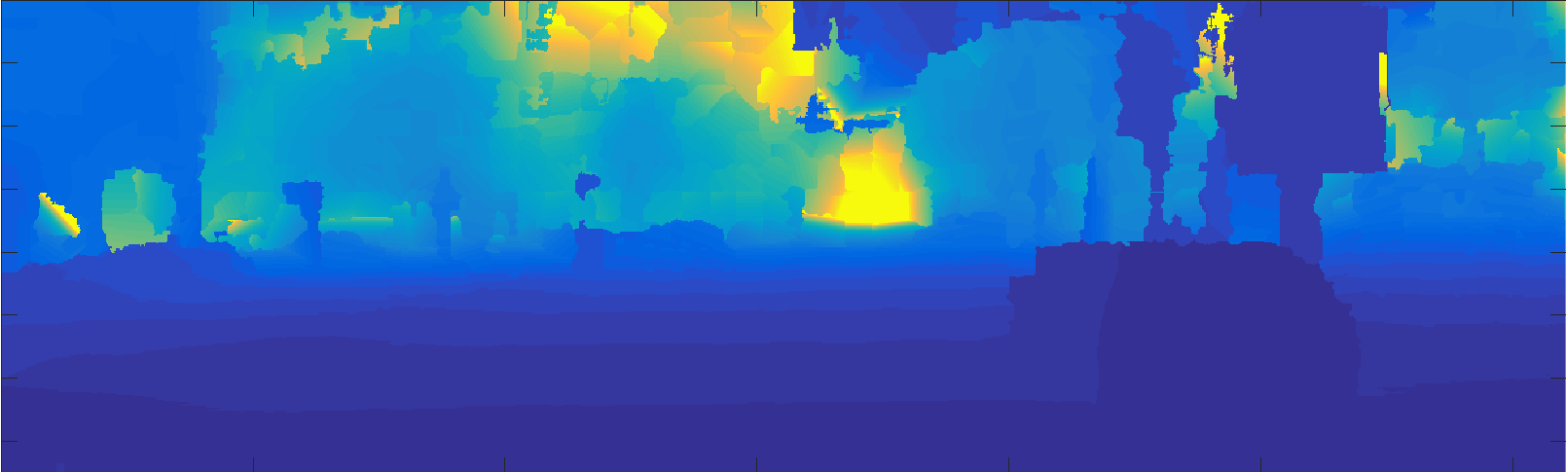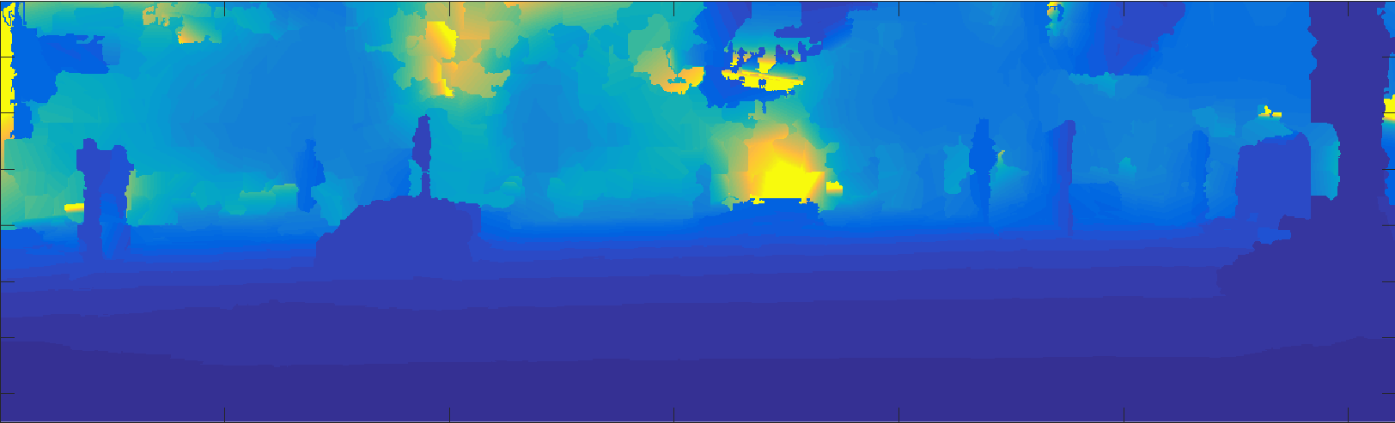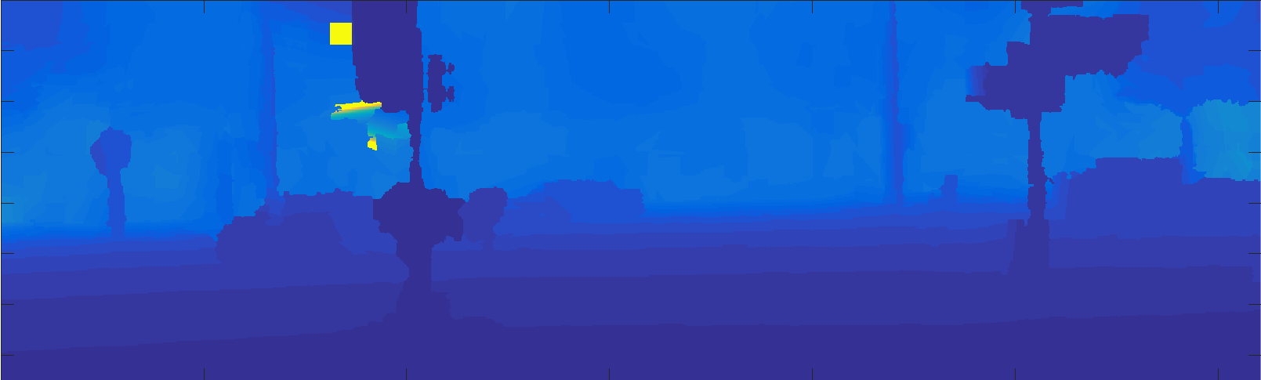

**b):**

**Detect object**

**Detect_object.m:**

function [ds, bs] = detectObject(detectorType, imname, model_thresh, nms_thresh)

data = getData([], [], detectorType);

model = data.model;

col = 'r';

imdata = getData(imname, 'test', 'left');

im = imdata.im;

f = 1.5;

imr = imresize(im,f); % if we resize, it works better for small objects

% detect objects

fprintf('running the detector, may take a few seconds...\n');

tic; % measure running time

[ds, bs] = imgdetect(imr, model, model_thresh); % you may need to reduce the threshold if you want more detections

e = toc;

fprintf('finished! (took: %0.4f seconds)\n', e);

% non maximum suppression

top = nms(ds, nms_thresh);

if model.type == model_types.Grammar

bs = [ds(:,1:4) bs];

end

if ~isempty(ds)

% resize back

ds(:, 1:end-2) = ds(:, 1:end-2)/f;

bs(:, 1:end-2) = bs(:, 1:end-2)/f;

end;

% showboxesMy(im, reduceboxes(model, bs(top,:)), col);

fprintf('detections:\n');

ds = ds(top, :);

**Q2_b.m:**

globals;

test_fid = fopen(fullfile(TEST_DIR, 'test.txt'));

imname = fgetl(test_fid);

% detext car, cyclist, person for all test image and save into results

% save will overwrite the file if exist

while ischar(imname)

[car_ds, car_bs] = detectObject('detector-car', imname, -0.6, 0.1);

car_ds_filename = fullfile(RESULTS_DIR, strcat(imname, '_car_ds.mat'));

car_bs_filename = fullfile(RESULTS_DIR, strcat(imname, '_car_bs.mat'));

save(car_ds_filename, 'car_ds');

save(car_bs_filename, 'car_bs');

[cyclist_ds, cyclist_bs] = detectObject('detector-cyclist', imname, 0, 0.1);

cyclist_ds_filename = fullfile(RESULTS_DIR, strcat(imname, '_cyclist_ds.mat'));

cyclist_bs_filename = fullfile(RESULTS_DIR, strcat(imname, '_cyclist_bs.mat'));

save(cyclist_ds_filename, 'cyclist_ds');

save(cyclist_bs_filename, 'cyclist_bs');

[person_ds, person_bs] = detectObject('detector-person', imname, -0.6, 0.1);

person_ds_filename = fullfile(RESULTS_DIR, strcat(imname, '_person_ds.mat'));

person_bs_filename = fullfile(RESULTS_DIR, strcat(imname, '_person_bs.mat'));

save(person_ds_filename, 'person_ds');

save(person_bs_filename, 'person_bs');

imname = fgetl(test_fid);

end

fclose(test_fid);

**c):**

**Visualize detection**

**drawAndLabelBoxes.m:**

function drawAndLabelBoxes(ds, label, fig)

num_rows = size(ds, 1);

if num_rows > 0

for row = 1:num_rows

x_left = ds(row, 1); x_right = ds(row, 3);

y_top = ds(row, 2); y_bottom = ds(row, 4);

lineX = [ x_left, x_right , x_right , x_left , x_left ] ;

lineY = [ y_bottom , y_bottom, y_top , y_top , y_bottom ] ;

figure(fig);

hold on;

switch label

case 'car'

line( lineX , lineY, 'Color', 'r', 'LineWidth', 3 ) ;

case 'person'

line( lineX , lineY, 'Color', 'b', 'LineWidth', 3 ) ;

case 'cyclist'

line( lineX , lineY, 'Color', 'c', 'LineWidth', 3 ) ;

end

text(x_left, y_top, label, 'Color', 'w', 'FontSize', 16, 'FontWeight', 'bold');

end

end

**Q2_c.m:**

globals;

imnames = {'004945', '004964', '005002'};

for i = 1:length(imnames)

imname = imnames{i};

imdata = getData(imname, 'test', 'left');

im = imdata.im;

car_ds_data = getData(imname, 'test', 'car_ds');

car_ds = car_ds_data.car_ds;

person_ds_data = getData(imname, 'test', 'person_ds');

person_ds = person_ds_data.person_ds;

cyclist_ds_data = getData(imname, 'test', 'cyclist_ds');

cyclist_ds = cyclist_ds_data.cyclist_ds;

fig = figure;

imshow(im);

drawAndLabelBoxes(car_ds, 'car', fig);

drawAndLabelBoxes(person_ds, 'person', fig);

drawAndLabelBoxes(cyclist_ds, 'cyclist', fig);

% save result

result_name = fullfile('../results', strcat('q2_b_', imname, '.png'));

saveas(fig, result_name);

End

**Results:**

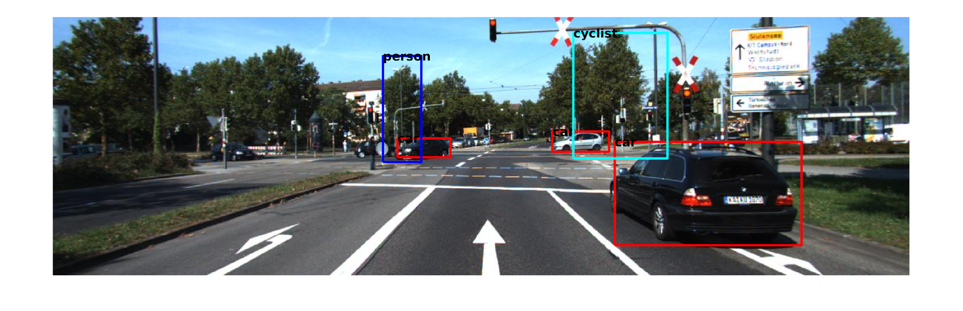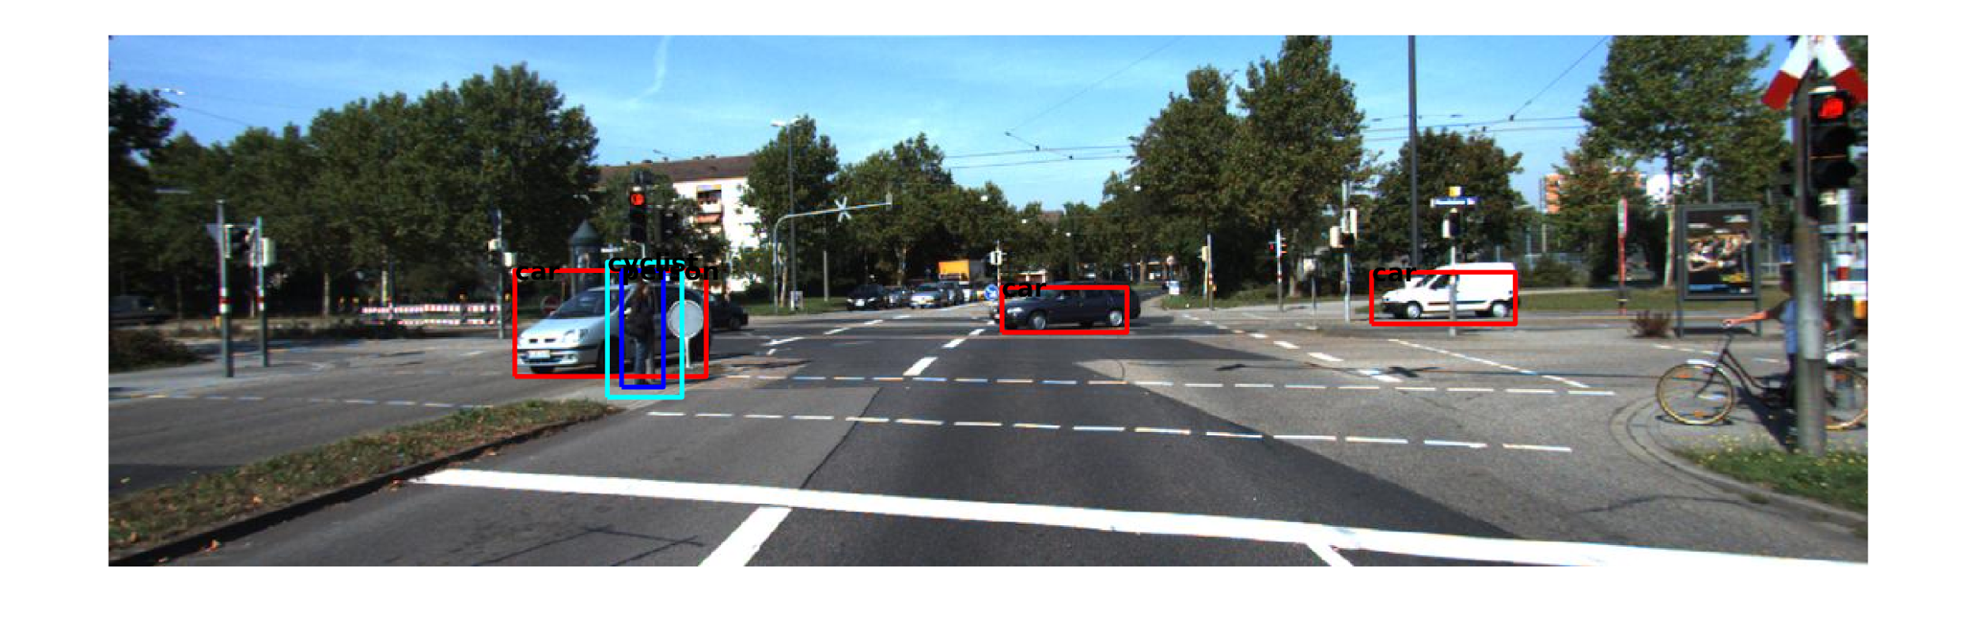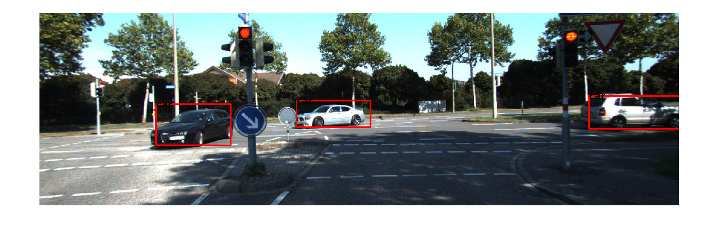

**d):**

**Compute 3D location**

**ComputeCenterLocation.m:**

function ds = computeCenterLocation(ds, location)

% given ds and corresponding 3d locations

% compute center location for each detection and store them back into ds

% col 7:9 in ds are center locations

num_detections = size(ds, 1);

num_rows = size(location, 1);

num_cols = size(location, 2);

if num_detections > 0

if size(ds, 2) == 6

ds = [ds zeros(num_detections, 3)];

end

for row = 1:num_detections

x_left = round(ds(row, 1)); x_left = min(max(x_left, 1), num_cols);

x_right = round(ds(row, 3)); x_right = min(max(x_right, 1), num_cols);

y_top = round(ds(row, 2)); y_top = min(max(y_top, 1), num_rows);

y_bottom = round(ds(row, 4)); y_bottom = min(max(y_bottom, 1), num_rows);

detection_location = location(y_top:y_bottom, x_left:x_right, :);

center_location = reshape(mean(mean(detection_location, 1), 2), [1 3]);

ds(row, 7:9) = center_location;

end

else

ds = zeros(0, 9);

End

**Q2_d.m:**

globals;

imnames = {'004945', '004964', '005002'};

for i = 1:length(imnames)

% get depth, K, car ds, person ds, cyclist ds

imname = imnames{i};

depth_data = getData(imname, 'test', 'depth');

depth = depth_data.depth;

calib_data = getData(imname, 'test', 'calib');

K = calib_data.K;

car_ds_data = getData(imname, 'test', 'car_ds');

car_ds = car_ds_data.car_ds;

person_ds_data = getData(imname, 'test', 'person_ds');

person_ds = person_ds_data.person_ds;

cyclist_ds_data = getData(imname, 'test', 'cyclist_ds');

cyclist_ds = cyclist_ds_data.cyclist_ds;

num_rows = size(depth, 1);

num_cols = size(depth, 2);

% compute and save 3d location for each pixel in image with name imname

location = zeros(num_rows, num_cols, 3);

for row = 1:num_rows

y = num_rows+1-row;

for col = 1:num_cols

x = col;

Z = depth(row, col);

result = K\[x; y; 1];

w = Z/result(3);

X = result(1)*w;

Y = result(2)*w;

location(row, col, :) = [X Y Z];

end

end

location_filename = fullfile(RESULTS_DIR, strcat(imname, '_location.mat'));

save(location_filename, 'location');

% compute and save center 3d location for each car detected

car_ds = computeCenterLocation(car_ds, location);

car_ds_filename = fullfile(RESULTS_DIR, strcat(imname, '_car_ds.mat'));

save(car_ds_filename, 'car_ds');

% compute and save center 3d location for each cyclist detected

cyclist_ds = computeCenterLocation(cyclist_ds, location);

cyclist_ds_filename = fullfile(RESULTS_DIR, strcat(imname, '_cyclist_ds.mat'));

save(cyclist_ds_filename, 'cyclist_ds');

% compute and save center 3d location for each person detected

person_ds = computeCenterLocation(person_ds, location);

person_ds_filename = fullfile(RESULTS_DIR, strcat(imname, '_person_ds.mat'));

save(person_ds_filename, 'person_ds');

End

**e):**

**Perform segmentation**

**Q2_e.m:**

globals;

imnames = {'004945', '004964', '005002'};

for i = 1:length(imnames)

imname = imnames{i};

% get location, ds and (center location)

location_data = getData(imname, 'test', 'location');

location = location_data.location;

car_ds_data = getData(imname, 'test', 'car_ds');

car_ds = car_ds_data.car_ds;

person_ds_data = getData(imname, 'test', 'person_ds');

person_ds = person_ds_data.person_ds;

cyclist_ds_data = getData(imname, 'test', 'cyclist_ds');

cyclist_ds = cyclist_ds_data.cyclist_ds;

% concatenate all ds together

all_ds = [cyclist_ds; car_ds; person_ds];

num_rows = size(location, 1);

num_cols = size(location, 2);

num_detections = size(all_ds, 1);

segmentation = zeros(num_rows, num_cols);

% find and label all pixel that is segmented

for j = 1:num_detections

center_location = all_ds(j, 7:9);

x_left = round(all_ds(j, 1)); x_left = min(max(x_left, 1), num_cols);

x_right = round(all_ds(j, 3)); x_right = min(max(x_right, 1), num_cols);

y_top = round(all_ds(j, 2)); y_top = min(max(y_top, 1), num_rows);

y_bottom = round(all_ds(j, 4)); y_bottom = min(max(y_bottom, 1), num_rows);

for col = x_left:x_right

for row = y_top:y_bottom

if norm(reshape(location(row, col, :), [1 3])-center_location) <= 15

segmentation(row, col) = j;

end

end

end

end

fig = figure;

imagesc(segmentation);

truesize(fig);

% save result

result_name = fullfile('../results', strcat('q2_e_', imname, '.png'));

saveas(fig, result_name);

End

**Results:**

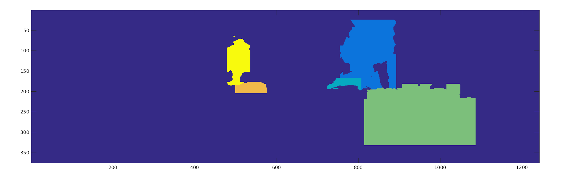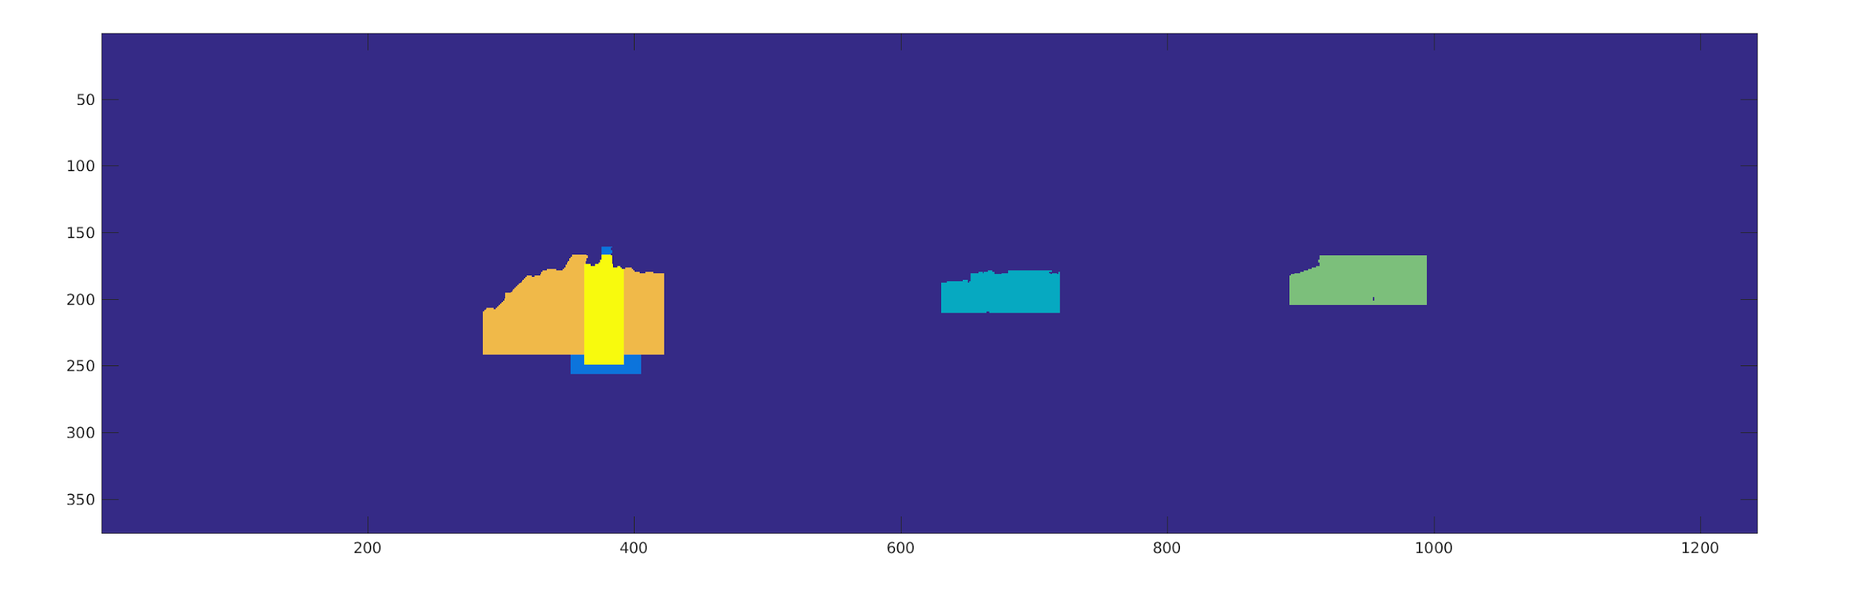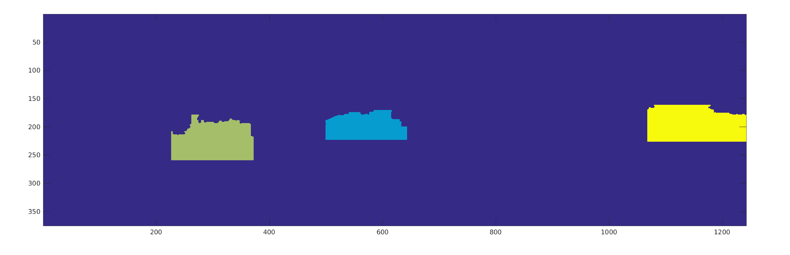

**f):**

**Create textual description**

**Q2_f.m:**

globals;

imnames = {'004945', '004964', '005002'};

for i = 1:length(imnames)

imname = imnames{i};

% get ds and (center location)

car_ds_data = getData(imname, 'test', 'car_ds');

car_ds = car_ds_data.car_ds;

person_ds_data = getData(imname, 'test', 'person_ds');

person_ds = person_ds_data.person_ds;

cyclist_ds_data = getData(imname, 'test', 'cyclist_ds');

cyclist_ds = cyclist_ds_data.cyclist_ds;

num_car = size(car_ds, 1);

num_person = size(person_ds, 1);

num_cyclist = size(cyclist_ds, 1);

% concatenate ds together, label car as 1, person as 2, cyclist as 3

all_ds = [car_ds; person_ds; cyclist_ds];

all_ds(1:num_car, 10) = 1;

all_ds(num_car+1:num_car+num_person, 10) = 2;

all_ds(num_car+num_person+1:num_car+num_person+num_cyclist, 10) = 3;

num_detections = size(all_ds, 1);

% find closed object type and distance

closest_distance = inf(1);

closest_object = 'unknown';

left_right = 'unknown';

for j = 1:num_detections

distance = norm(all_ds(j,7:9));

if distance < closest_distance

closest_distance = distance;

if all_ds(j, 7) < 0

left_right = 'left';

else

left_right = 'right';

end

switch all_ds(j, 10)

case 1

closest_object = 'car';

case 2

closest_object = 'person';

case 3

closest_object = 'cyclist';

end

end

End

% print textual description

fprintf('for image %s: %d car, %d person, and %d cyclist are detected.\n',...

imname, num_car, num_person, num_cyclist);

fprintf('There is a %s on your %s, which is %d meters away from you\n\n',...

closest_object, left_right, round(closest_distance));

End

**Results:**

for image 004945: 3 car, 1 person, and 1 cyclist are detected.

There is a car on your right, which is 12 meters away from you

for image 004964: 3 car, 1 person, and 1 cyclist are detected.

There is a person on your left, which is 23 meters away from you

for image 005002: 3 car, 0 person, and 0 cyclist are detected.

There is a car on your left, which is 24 meters away from you